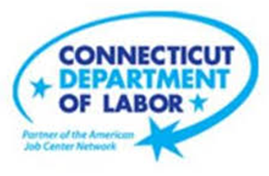

**NEW WEEKLY JOB POSTINGS FROM   
HELP WANTED ONLINE  
Office of Research**

**Week Ending July 17th, 2021 –   
Total New Ads Fall to 5,218 Driven by Health Care & Social Assistance**

WETHERSFIELD, July 23rd, 2021 – During the week ending July 17th, 2021, there were 5,218 new postings, down 32% from a week ago and down 21% from four weeks ago. This most recent week of total new ads is the lowest since early April. About 61% of the 2,499 decline over the week occurred in Health Care & Social Assistance. Employers with the largest drops were Hartford Healthcare (-456 new ads), The Hartford Financial Group (-45 new ads) and Connecticut Children’s Medical Center (-42 new ads). The occupations with the largest over the week declines include Registered Nurses (-342 new ads), Medical & Health Service Managers (-88 new ads), and Retail Salespersons (-79 new ads). Amid large overall weekly declines, employers that added the most new job ads include Amazon (+96 new ads), CVS Health (+41 new ads), and Yale-New Haven Health System (+38 new jobs).  
  
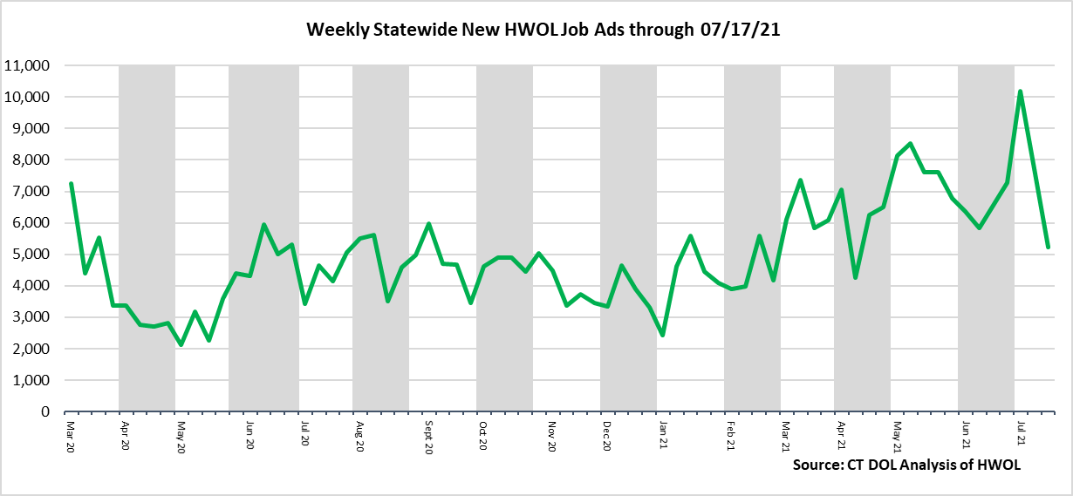

**Industries** with the most new postings include Health Care & Social Assistance, Retail Trade, and Accommodation & Food Service.

**Occupations** with the most new postings include Retail Salespersons, Registered Nurses, and Wholesale & Manufacturing Sales Representatives.

**Employers** with the most new postings include Amazon, Yale-New Haven Health System, and Hartford Healthcare.

**The three industries with the most new job postings where**

* **Health Care & Social Assistance** (804 new postings, -66% over the week)
* **Retail Trade** (787 new postings, -0.3% over the week)
* **Accommodation & Food Service** (528 new postings, +45% over the week)



Fourteen sectors had job posting decreases over the week, one was unchanged and six had increases. The 14 increasing industries fell by a combined 2,736 new ads over the week while the six increasing industries grew by a combined 237 new ads. Health Care and Social Assistance (-1,524 new ads) made up about 55 percent of the decline, and most of the gains among the six increasing industries occurred in Accommodation & Food Service (+163 new ads). That sector had the third highest count of job ads during the past week and displaced Finance and Insurance, which is usually in the top three.

For more information on total job ads by industry for Connecticut and its labor market areas, see the monthly report available here: <https://www1.ctdol.state.ct.us/lmi/hwol.asp>

**New Job Postings by Occupation**



**The occupations with the most new postings were:**

* Retail Salespersons (189 new postings, -27% over the week)
* Registered Nurses (180 new postings, -66% over the week)
* Sales Representatives, Wholesale and Manuf. (151 New Postings, +0.7% over the week)

**Employers with the Most New Job Postings** 

Employers with the most new job postings during the week were mostly in Healthcare, Retail Trade, and Finance & Insurance. The 25 employers shown above account for 20 percent of all new ads. Of the top 25 employers, 18 had over the week increases and 7 had decreases. Among increasing employers, Amazon (+96 new ads), CVS Health (+41 new ads), and Yale-New Haven Health System (+38 new ads) had the largest over the week increases. The 7 decreasing employers in the top 25 fell by a combined 484 new ads and most of that decline occurred at Hartford Healthcare (-456 new ads). That decrease corresponds with a 446 new ad increase during the prior week at Hartford Healthcare. Over Four weeks, the largest increase and decrease among top 25 employers were both in Retail Trade, Macys (+39 new ads) and Walgreens Boots Alliance Inc (-29 new ads).  
  
**What is HWOL?**The **Conference Board Help Wanted Online**® Data Series (HWOL) measures the number of new, first-time Online job postings and jobs reposted from the previous month for over 16,000 Internet job boards, corporate boards and smaller job sites that serve niche markets and smaller geographic areas. To view more HWOL data, go to: [**https://www1.ctdol.state.ct.us/lmi/pubs/HWOL2020.pdf**](https://www1.ctdol.state.ct.us/lmi/pubs/HWOL2020.pdf)